DRAFT SAMPLE EXAMINATION
MARKING KEY

2008/38961

Copyright
© Curriculum Council, 2008
This document—apart from any third party copyright material contained in it—may be freely copied, or communicated on an intranet, for non-commercial purposes by educational institutions, provided that it is not changed in any way and that the Curriculum Council is acknowledged as the copyright owner.
Copying or communication for any other purpose can be done only within the terms of the Copyright Act or by permission of the Curriculum Council.
Copying or communication of any third party copyright material contained in this document can be done only within the terms of the Copyright Act or by permission of the copyright owners.

Section One 40 Marks

Question 1 (4 marks)
(a), (b)

Description | Marks
(a) 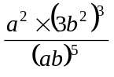= 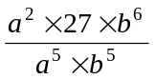 ✓ = 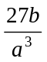 ✓  (b) 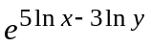 = 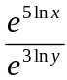 ✓ = 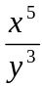 ✓ | 4

Question 2 (5 marks)
(a), (b) , (c)

Description | Marks
(a) 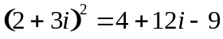 ✓ = 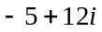 ✓  (b) 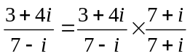 ✓ 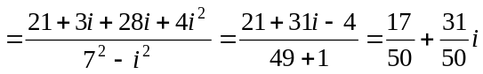 ✓  (c) 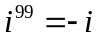 ✓ | 5

Question 3 (4 marks)

Description | Marks
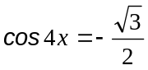  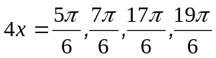 ✓✓ (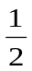 mark each, rounded down to the nearest whole number)  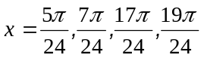 ✓✓ | 4

Question 4 (6 marks)

Description | Marks
The graph has a vertical translation of 3; i.e. 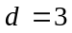 ✓  The graph has an amplitude of 2; i.e. 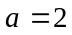 ✓  The graph completes a cycle in every radians; ✓ i.e. 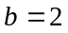 ✓  The graph has a horizontal translation of 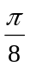; ✓ i.e. 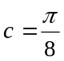 ✓ | 6

Question 5 (4 marks)
(a), (b)

Description | Marks
(a) 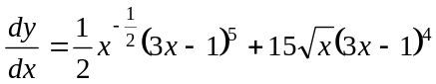 ✓✓ (1 mark for correct use of product rule;  1 mark for correct differentiation)  (b) 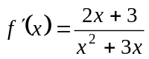 ✓✓ (1 mark for numerator, 1 mark for  denominator) | 4

Question 6 (5 marks)

Description | Marks
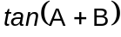 = 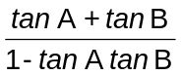 ✓  i.e. 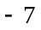 = 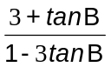 ✓  i.e. 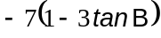 = 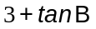 ✓  i.e. 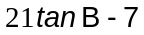 = 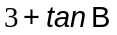  i.e. 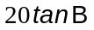 = 10 ✓  i.e. 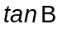 = 0.5 ✓ | 5

Question 7 (6 marks)
(a), (b)

Description | Marks
(a) a = 1 ✓  c = 4 ✓  (b) 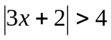  i.e. 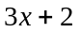 > 4 or 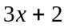 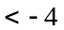 ✓  i.e. 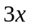 > 2 or 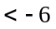 ✓  i.e. > ✓  or 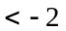 ✓ | 6

Question 8 (6 marks)
(a), (b), (c)

Description | Marks
(a) 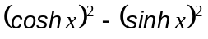 = 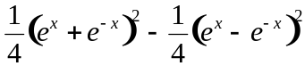 ✓  = 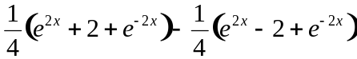 ✓  = 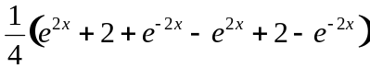 ✓  = 1  (b) 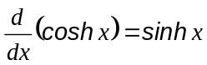  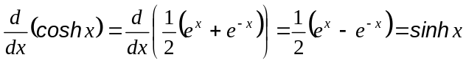 ✓  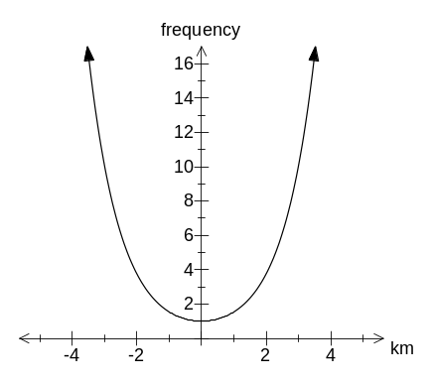  (c)  The graph passes through (0, 1) ✓  The general shape is correct ✓ | 6

Section Two

Question 9 (8 marks)
(a), (b)

Description | Marks
(a) and (b)  Without a CAS calculator  Let a, b, and c denote the vector displacements corresponding to the first three parts of his run, and let i and j denote unit vectors pointing east and north respectively. Then  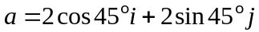 = 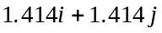 ✓ 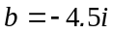 ✓ 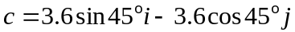 = 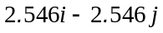 ✓  So the total displacement is  ✓  So if d is the displacement vector corresponding to his return to the starting position, then  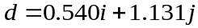  Now 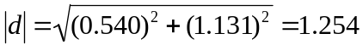, ✓  i.e. the runner is 1.25 km from the starting point. ✓  Also if 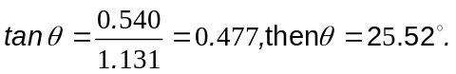 ✓  So the direction back to the starting point is 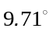 west of north ✓  (i.e. a bearing of 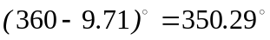).  OR  With a CAS calculator:  Let a, b, and c denote the vector displacements corresponding to the first three parts of his run, and let i and j denote unit vectors pointing east and north respectively. Then  a = toRect([2,∠(π/4)]) = ✓  b = toRect([4.5,∠(π)]) = 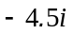 ✓  c = toRect([3.6,∠(7π/4)]) = ✓  So the total displacement is ✓  So if d is the displacement vector corresponding to his return to the starting position, then  ✓  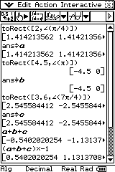  i.e. d = toPol([0.540,1.131]) = [1.2537,∠1.12533] ✓  i.e. the runner is 1.25 km from his starting point ✓  and his required true bearing is 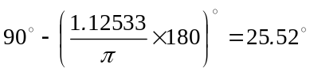 ✓  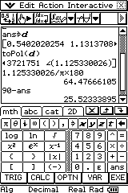 | 8

Question 10 (4 marks)
(a), (b)

Description | Marks
(a) Require the dot product of 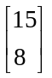 and 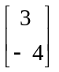 ✓  Using the vector facilities of a CAS calculator gives the angle 81.20º ✓  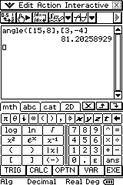  (b) No, 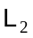 does not pass through the origin. ✓  The Cartesian equation of is 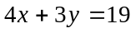, which has a y-intercept of 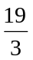 ✓ | 4

Question 11 (5 marks)
(a), (b), (c)

Description | Marks
(a) ✓✓  (b) (to the nearest whole number) ✓  (c) Perth’s velocity would be slower than Jakarta’s. ✓  Both cities complete one revolution every 24 hours. However, Jakarta is closer to the equator and has a larger circle of latitude and so has further to travel. ✓ | 5

Question 12 (5 marks)
(a), (b), (c)

Description | Marks
(a) A: 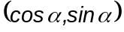 ✓  B: 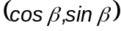 ✓  (b) (i) 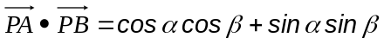 ✓  (ii) ✓  (c) But  Hence ✓ | 5

Question 13 (4 marks)

Description | Marks
Let Jodie’s weight after t weeks be J(t) kg. Then 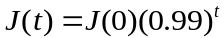 ✓  Let Kevin’s weight after t weeks be K(t) kg. Then 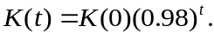 ✓  If then 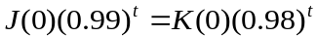  i.e. 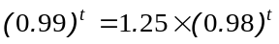 (since ✓)  Using a calculator to solve gives 21.98 weeks ✓  i.e. it will take 22 weeks for Jodie and Kevin to have the same weight. | 4

Question 14 (9 marks)
(a), (b)

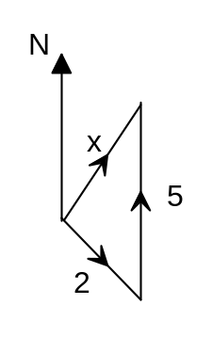  Description  θ°  45°  θ° | Marks
(a) (✓✓ for the diagram)  Use a calculator to solve the triangle:  The kayak is travelling at a speed of 3.855 km/h ✓  at a bearing of 21.5 degrees east of north. ✓  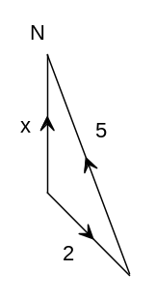  (b) (✓✓✓ for the diagram)  θ°  Use a calculator to solve the triangle:  The kayak is travelling at a speed of 3.38 km/h ✓  135°  The bearing is 16.4° west of north;  i.e. a true bearing of 345.6°. ✓ | 9

Question 15 (9 marks)
(a), (b), (c)

Description | Marks
(a) 0n arc BC, 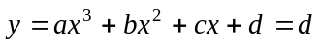 when 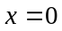.  Therefore, since the curve is continuous at B, ✓ On the arc BC 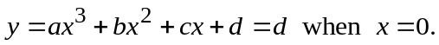 Therefore, since the curve is continuous at B, d = 0. ✓  Also 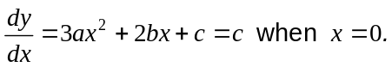  Therefore, since the derivative of the curve is continuous at B, c = 0 ✓  (b) On the arc BC  Therefore, since the curve is continuous at C, 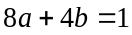 ✓  Also 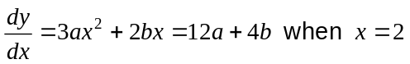  Therefore, since the derivative is continuous at C, and the gradient of the line segment CD is 2, 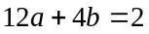 ✓  Solving simultaneously gives 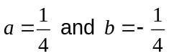. ✓  (c) On the straight line segments the second derivative is 0. ✓  On the arc BC, since 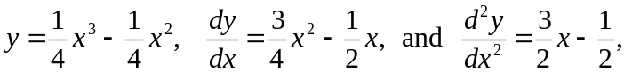 ✓  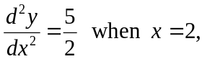 and 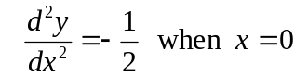 ✓  So the greatest change in the second derivative occurs at the point C. ✓ | 9

Question 16 (7 marks)
(a), (b), (c), (d), (e)

Description | Marks
(a) 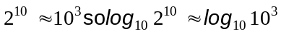  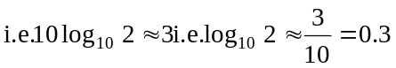 ✓  (b) 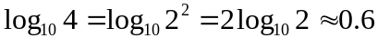  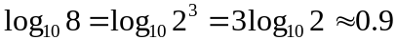 ✓  (c) 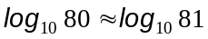  i.e.  i.e. 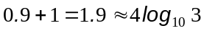  i.e. 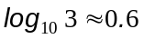 ✓  (d) ✓  (e) The numbers 2, 4, 6, and 8 are the mid-points of the intervals [1,3], [3,5], [5,7] and [7,9], and the width of each of these intervals is 2. ✓  So an estimate of the integral is ✓  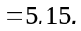 ✓ | 7

Question 17 (12 marks)
(a), (b), (c), (d), (e), (f), (g)

Description | Marks
(a) 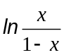 is defined when 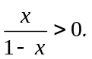 ✓  This occurs when 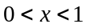  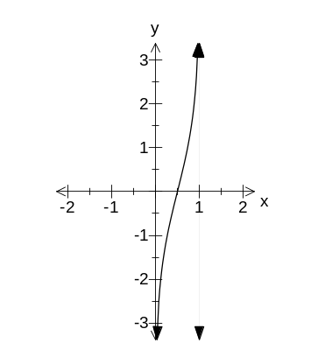This is the domain of 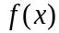 ✓  (b)  ✓✓ (1 mark for shape, 1 for asymptote x=1)  (c) From the graph the range is 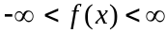 ✓  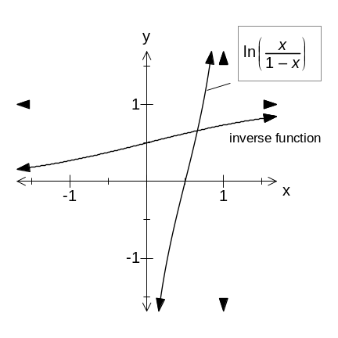(d) Using a CAS calculator the tangent line is 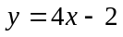 ✓✓  (e)  ✓✓ (1 mark for shape, 1 for asymptote y=1)  (f) The domain of 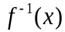 is the entire real line ✓  and its range is the interval ✓  (g) 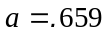 ✓ | 12

Question 18 (4 marks)

Description | Marks
Let be the length of the radius and radians be the central angle.  Then 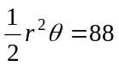 ✓ and ✓  Solving simultaneously on a CAS calculator gives 2 solutions:  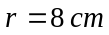 and 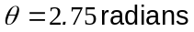 ✓  OR 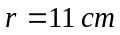 and 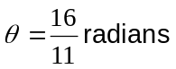 ✓  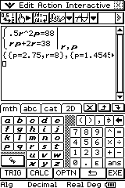 | 4

Question 19 (6 marks)
(a), (b), (c)

Description | Marks
(a) 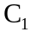 has equation 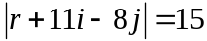 ✓  (b) 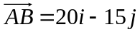  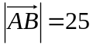 ✓  But the sum of the radii of the two circles is also 25 units. ✓  Hence the two circles touch.  (c) 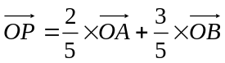 ✓  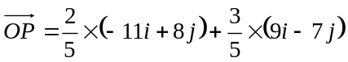 ✓  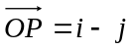 ✓  Or 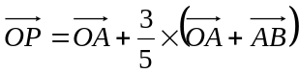 ✓  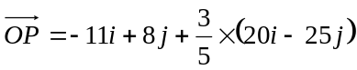 ✓  ✓ | 6

Question 20 (7 marks)
(a), (b), (c)

Description | Marks
(a) RS = 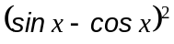  RS = 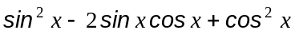 ✓  RS = 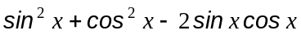 ✓  RS = 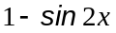 = LS ✓ (This proof can work backwards if starting from LS.)  (b) LS = 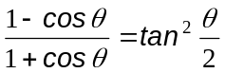  LS = 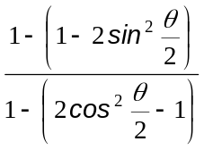 ✓✓ (one mark for numerator, one for denominator)  LS = 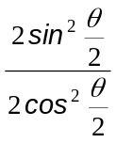 ✓  LS = 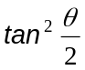 = RS ✓ | 7

Mathematics: Specialist Units 3AMAS AND 3BMAS

Draft sample examination
Mapping questions to content
Question number | Vectors | Trigonometry | Exponentials and logarithms | Functions | Mathematical reasoning | Complex numbers  Polar coordinates | Content from 3AMAS syllabus | Content from 3BMAS syllabus
Section One: Calculator-free
1 |  |  | ✓  4 marks |  |  |  | 3.1 develop and use the index laws for positive bases and rational exponents  3.2 establish and use the properties of exponential functions  3.3 develop the inverse relationship between logarithmic and exponential functions: 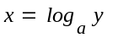and 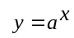  3.5 use the laws of logarithms
2 |  |  |  |  |  | ✓  5marks |  | 6.5 add, subtract, multiply and divide complex numbers in Cartesian form
3 |  | ✓  4 marks |  |  |  |  |  | 2.5 solve trigonometric equations of the form  sin(ax) = k, cos(ax) = k and tan(ax) = k for a given finite domain.
4 |  | ✓  6 marks |  |  |  |  |  | 2.2 investigate the transformations of sine, cosine and tangent functions such as y = a sin b(x + c) + d and identify the effects of the constants a, b, c and d on amplitude, period, phase, and the locations of zeros and turning points (see 3AMAS 4.6)  2.3 use appropriate technology to investigate and represent diagrammatically the roles of a, b, c and d in the linear scale changes studied in 2.2 above
5 |  |  | ✓  2 marks | ✓  2 marks |  |  |  | 4.6 apply the chain rule with appropriate notation to differentiate composite functions  4.7use the product and quotient rules to differentiate polynomial, exponential (base e) and natural logarithmic functions.  3.5 differentiate exponential and logarithmic functions including e^{f(x)} and ln[f(x)].
6 |  | ✓  5 marks |  |  |  |  |  | 2.4 use the addition and double angle formulas for sine, cosine and tangent:
7 |  |  |  | ✓  6 marks |  |  | 4.5 solve, algebraically and geometrically, simple equations and inequalities involving absolute values of linear functions
8 |  |  | ✓  6 marks |  |  |  |  | 3.5 differentiate exponential and logarithmic functions including e^{f(x)} and ln[f(x)].
Section Two: Calculator-allowed
1 | ✓  8marks |  |  |  |  |  | 1.6 establish and use the formula 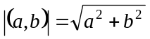 for the magnitude or modulus of a vector as its length in the plane  1.8 use the parallelogram law or triangle law of vector addition and the triangle inequality 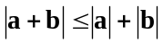 | 1.6 solve practical problems using vectors including. the study of bearings, forces and navigation problems involving apparent and true velocities.
2 | ✓  4marks |  |  |  |  |  |  | 1.1 develop the concept of the dot product of vectors in a plane, using projections, and the formula 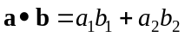, and establish the formula 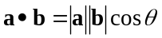where a 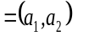and b 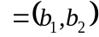  1.3 establish and use the vector equation of a line in the plane in its various forms:  one point and slope: r = r₁+l  two points:  r = r₁ + (r₂ – r₁)  normal:
3 |  | ✓  5 marks |  |  |  |  | 2.7 solve practical problems; including angles of elevation and depression, surveying, bearings and navigation distances along circles of constant latitude or constant longitude on the surface of the Earth.
4 | ✓  3 marks |  |  |  |  | ✓  2 marks | 7.2 use the relationship between Cartesian and polar coordinates in the plane and convert from one system to the other. | 1.1 develop the concept of the dot product of vectors in a plane, using projections, and the formula , and establish the formula where a and b  1.2 calculate the angle between two vectors and identify parallelism and perpendicularity
5 |  |  | ✓  4 marks |  |  |  | 3.6 solve growth and decay problems using exponential and logarithmic functions.
6 | ✓  9 marks |  |  |  |  |  |  | 1.6 solve practical problems using vectors including the study of bearings, forces and navigation problems involving apparent and true velocities.
7 |  |  |  | ✓  9 marks |  |  |  | 4.1 investigate the continuity and limiting behaviour of functions  4.3 investigate the differentiability of functions using limits
8 |  |  | ✓  7 marks |  |  |  | 3.5 use the laws of logarithms
9 |  |  |  | ✓  12 marks |  |  | 3.4 investigate and use the properties of the logarithmic functions 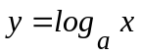 for  a > 0, and draw their graphs  4.2 identify the domain and range of simple functions and their composites  4.4 investigate relationships between domains and ranges of functions and their inverses
10 |  | ✓  4 marks |  |  |  |  | 2.2 determine arc lengths in circles, exactly and approximately  2.4 determine areas of sectors and segments in circles using exact and approximate values as appropriate
11 | ✓  6 marks |  |  |  |  |  | 1.9 multiply a vector by a scalar and subdivide line segments internally | 1.4 establish and use the vector form of the equation of a circle in the plane: 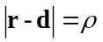
12 |  |  |  |  | ✓  7 marks |  |  | 5.5 prove simple trigonometric identities by deduction, using the properties listed in 2.1 and 2.4 above
Total marks | 30 | 24 | 23 | 29 | 7 | 7
% | 25% | 20% | 19% | 24% | 6% | 6%
Should be | 20-25% | 15-20% | 15-20% | 20-25% | 5-10% | 5-10%

